THE IHCA CALLS FOR INCREASED FUNDING TO DELIVER QUALITY, SAFE CARE TO PATIENTS IN ACUTE HOSPITALS AND MENTAL HEALTH SERVICES
Dublin, 24th July 2014: The Irish Hospital Consultants Association (IHCA) has expressed its concern that underfunding of hospital and mental health services is threatening patient care. The Association called for additional resources to be allocated to acute hospitals in the 2015 Budget, ensuring the delivery of safe, quality care to patients.
The IHCA today launched its pre-budget submission detailing seven key areas which the Association believes need to be addressed by the new Minister for Health in the upcoming Budget.
The IHCA stated that there is a pressing need to increase frontline acute hospital resources in the 2015 Budget otherwise the delivery of care to patients will be adversely affected leading to increased delays and growing numbers of patients on waiting lists. The total health budget provisions for acute hospitals and mental health services have been cut excessively during the past five years of austerity. Recent budgets have not been based on realistic estimates of patient demand. It is essential that increased funding for these frontline services is provided in the 2015 Budget, especially as the country’s economic circumstances continue to improve.
Commenting on its pre-budget submission, Dr Gerard Crotty, President of the IHCA said:
“It is a major concern that budgets for acute hospitals have been cut to unrealistic levels such that, in the first five months of 2014, acute hospital expenditure was €104.8m over-budget. The vast majority of hospitals are grossly underfunded with some overspending by up to 21%. Funding for acute hospital services has been cut by almost one fifth compared with the resources in place in 2008. If increased resources are not provided in the 2015 Budget it will increase the risk that a growing number of patients will not be treated within a medically appropriate timeframe.”
“Alarmingly, there were 50,689 patients awaiting elective care in May 2014 representing a 5% increase on May 2013. It is clear that the deep acute hospital budget cuts have increased the number of patients awaiting treatment and it is essential that hospital budgets are based on more realistic estimates of projected demand. The Association strongly recommends that increased resources are provided in Budget 2015 in order to utilise the existing bed and theatre capacity to the optimum.”
The IHCA’s pre-budget submission also called for increased frontline hospital staffing to ensure the delivery of safe, high quality care to patients without delays. The submission calls for the restoration of tax relief on health insurance to the levels that pertained prior to the last budget. It recommends increased funding and staff levels to improve Mental Health Services. The Association has highlighted the urgent need to reverse the 30% unilateral cut in new Consultant salaries so that Ireland can attract and retain the calibre and number of Consultants needed to provide care to patients without delay.
Key statistics noted in the submission include the following:
- Total health spending in Ireland accounted for 8.9% of GDP which is significantly below the OECD average. Health spending, as a share of GDP is much lower in Ireland than in other European Countries such as Austria, Denmark, France, the Netherlands, Germany and Switzerland where it accounts for 11% or more of GDP.

- Funding for acute hospitals has been cut by almost a fifth or around €873m since 2008, at a time when the number of in-patients and day case patients has increased from 1.2m to 1.43m.

- In the first five months of 2014, 46 of the 49 acute hospitals were over budget, as reported in the HSE May 2014 Performance Report.

- The number of day-case patients treated in 2013 was 42% or 246,117 cases higher than in 2007. However, in the first 5 months of this year, 12,500 (-3.5%) fewer day-case patients were treated than in the same period last year. This has given rise to an increase in elective waiting lists.
- The number of people awaiting elective care increased by 5% to 50,689, of which 4,649 were children, in the year to May 2014.
- The number of clinically discharge patients occupying acute hospital beds continues to be around 670, which is equivalent to Beaumont Hospital or University Hospital Galway being closed to new admissions throughout the year.
- Mental Health funding has been cut by almost €250m, or 25% since 2009, while simultaneously, Child and Adolescent Mental Health Services have reported an increase in the numbers on waiting lists to 3,029 cases, representing an 11% increase on the same period last year.
- Currently, Ireland has approximately two thirds the number of Hospital Consultants recommended a decade ago in the Hanly Report. In the interim, the demand for care has grown substantially due to the country’s increasing and ageing population. In some specialties, Ireland has around one third to half the number of Hospital Consultants it needs and compared with the recommended international norms.
- Based on OECD Health at Glance, Ireland has 2.7 doctors per thousand of population, which is 15% fewer doctors than the OECD average of 3.2 per thousand and about 30% fewer doctors than Austria, France, Italy, Germany, Spain, Sweden and Switzerland.
ENDS
For further information or to arrange an interview with the IHCA, please contact:
Maria McGrath, FleishmanHillard - +353861653055 or Maria.McGrath@fleishmaneurope.com
Julian Davis, FleishmanHillard - +353862531269 or Julian.Davis@fleishmaneurope.com

About the IHCA
The Irish Hospital Consultants Association was established to promote, encourage and support the advancement of the practice of Medicine, in all specialties and areas, and the improvement of the Health Services in Ireland. There are over 2,400 members of the Association and it is widely recognised as the leading representative voice for the profession in Ireland.

PRE-BUDGET Submission: 2015

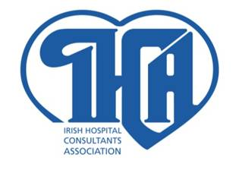

24 JULY 2014

Submission by:
THE IRISH HOSPITAL CONSULTANTS ASSOCIATION
HERITAGE HOUSE, TELEPHONE: 01 2989123
DUNDRUM OFFICE PARK FAX: 01 2989395
DUNDRUM E-MAIL: info@ihca.ie
DUBLIN 14 WEB: www.ihca.ie

Contents

Summary 3
1. Introduction 4
2. Increased Frontline Acute Hospital Resources Required 4
3. Patient Demand for Acute Hospital Care continues to exceed NSP targets. 8
4. Waiting Lists. 10
5. Health Insurance 14
6. Mental Health Funding 14
7. Staffing Issues. 15
8. Conclusion 15

Summary

Increased frontline acute hospital resources required.
There is a pressing need to increase frontline acute hospital resources in the 2015 Budget to enable the delivery of high quality, safe care to patients in contrast with the current overstretched situation. Otherwise, the delivery of care will be adversely affected leading to increased delays in treating patients and growing numbers on waiting lists. It is a major concern that budgets for acute hospitals have been cut to an unrealistic level such that acute hospital expenditure in the first five months of 2014 was €104.8m over budget. The vast majority of hospitals are grossly underfunded with some overspent by up to 21%. If increased resources are not provided, it will increase the risk that a growing number of patients will not be treated within a medically appropriate timeframe. Underfunding of acute hospitals is a matter that needs to be urgently addressed in the 2015 Budget.

Patient demand for acute hospital care continues to exceed National Service Plan (NSP) targets.
The successive reductions in acute hospital budgets have restricted the delivery of acute services over the last number of years. The number of day case patients treated up to May 2014 has declined by 12,500 or 3.5% due to the rationing of care. Increased funding for acute hospitals is required to address the constraints applying to acute service delivery.

Waiting lists.
The Association strongly recommends that increased frontline resources are provided to utilise the existing bed and theatre capacity to the optimum as this is urgently required to treat the increasing numbers of patients presenting for care. The failure to transfer clinically discharged patients to step down care is the equivalent to Beaumont Hospital or University Hospital Galway being closed throughout the year every year. Closed beds and restricted access to theatre facilities and beds in operation represent an enormous loss to the health system and wider public.

Health Insurance.

Given the continuing upward pressure on the cost of providing care, it is critically important that the increased cost of clinical indemnification is addressed and that tax relief on private health insurance is returned to the levels that applied prior to the 2014 budget cuts.

Mental Health Funding.
The €20 million of ring fenced investment in Mental Health Services in the 2014 Budget must be used on a timely basis to recruit additional staff and improve care for patients. This funding should be increased in next year’s budget to improve staffing levels further.

Staffing Issues.
It is essential that the Consultant recruitment and retention crisis that is causing a medical brain drain is addressed urgently. The unilateral 30% cut in new Consultant salaries introduced in October 2012 in breach of the Croke Park Agreement must be reversed to ensure the country can recruit and retain the number and calibre of Consultants it needs.

- Introduction

The total health budget and in particular the budget provisions for acute hospitals and mental health services have been cut disproportionately during the past five years of austerity. It is widely recognised that the current budget provisions for the frontline delivery of these health services are insufficient. Recent budgets have not been based on realistic estimates of patient demand. It is essential that increased funding for these frontline services is provided in the 2015 Budget, especially now that the financial circumstances for the country and the economy are improving.

- Increased Frontline Acute Hospital Resources Required
  - The number of inpatient and day case patients treated in 2013 was 1,431,898, which is a 15% increase on 2008. Up to May this year 588,921 inpatients and day case patients have been treated; 4,958 patients (0.8%) above the year to date target in the NSP. However, it represents a decrease of 11,970 patients (-2%) on the number of patients treated in the same period last year, when 600,891 patients were treated. This creates a significant concern that the substantial cuts in hospital budgets are negatively impacting on the delivery of timely patient care.

  - Acute hospitals have been significantly underfunded in recent years, with end of year deficits before inclusion of supplementary budgets of €280m (7.7%) and €70m (1.8%) in 2012 and 2013 respectively. Funding for acute hospital services has been cut by almost a fifth, or around €873m since 2008 as demonstrated in Figure 1. Following health budgetary reductions of €3.3bn since 2008, the 2014 reductions of €619m bring the total reduction in the health budget to €3.92bn in six years.

Figure 1: Acute Hospital funding 2008 – 2014 (€' 000)
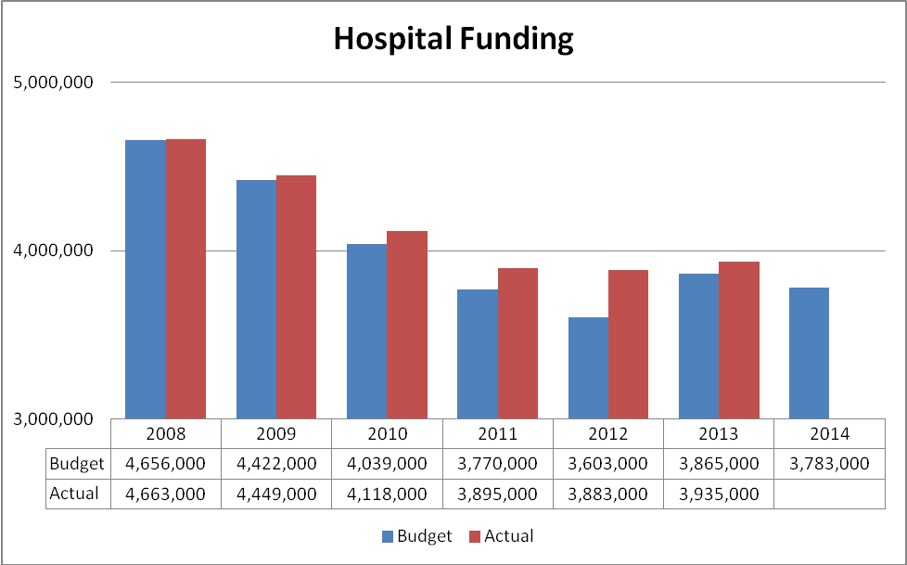

 | 2008 | 2009 | 2010 | 2011 | 2012 | 2013
Var | -7,000 | -27,000 | -79,000 | -125,000 | -279,000 | -70,000
% | -0.2% | -0.6% | -2.0% | -3.3% | -7.7% | 1.80%
Source: May 2014 HSE Performance Report and Annual Performance Reports.

  - It is a major concern that acute hospital expenditure to treat the number of patients requiring care up to May 2014 was €104.8 million above the funding levels that hospitals have received. The resultant and renewed pressures from management to cut spending back to within budget limits in the months ahead will prevent the optimum use of existing facilities and increase the rationing of acute services for patients leading to longer waiting lists. The comparable acute hospital overspend for the same period last year was €52.9m highlighting increased underfunding in the current year due to effects of the repeated budget cuts.

Figure 2: Acute Hospital & HSE Funding (January to May 2014)

 | Jan 14  €000’s | Feb 14  €000’s | Mar 14  €000’s | April 14  €000’s | May 14  €000’s
Total Acute Hospital Deficit | 20,300 | 39,500 | 63,400 | 81,200 | 104,800
Total HSE Budget Deficit | 24,500 | 54,800 | 80,400 | 107,500 | 163,000
Source: HSE Performance Reports

  - The overspends set out in Figure 2 reflect the fact that this year’s budget was not based on realistic estimates of the demand for acute hospital services. The delivery of care is being restricted due to the structural underfunding of frontline services and the deep budgetary cuts.

  - The total number of in-patients and day-case patients treated has increased from 1.20 million to 1.43 million (+19%) in the last 6 years, while acute hospital budgets have been cut from €4.66 to €3.86 billion (-17%). In terms of productivity and efficiency gains between 2007 and 2013, this equates to a 44% increase in the number of patients treated per euro of acute hospital budget or equivalent to a 30% decrease in the average cost per patient during the same period. If a private enterprise had achieved similar improvements it would be acknowledged as an exceptional achievement in contrast with the repeated negative commentary on the performance of our acute health services in what are extremely challenging circumstances.

  - In order to treat the number of patients presenting for care, eight acute hospitals at the end of May were over budget by between 10% and 21% and many others were over budget by lower percentages as outlined in Table 1. It is not possible for those hospitals to cut spending to stay within their annual budget limits without extremely adverse consequences for the delivery of care to patients. Overall, 46 of the 49 acute hospitals were overspent in May

Table 1: Deficits per selected acute hospitals in May 2014.
Hospital | Actual  €000’s | Budget  €000’s | Variance  €000’s | % Overspend
Portiuncula Hospital | 22,108 | 18,224 | 3,884 | 21.3%
University Hospital Limerick | 73,630 | 62,409 | 11,221 | 18%
South Tipperary General Hospital | 21,331 | 18,099 | 3,231 | 17.9%
Mercy University Hospital, Cork | 27,433 | 23,276 | 4,157 | 17.9%
Our Lady’s Hospital, Navan | 17,810 | 15,242 | 2,568 | 16.8%
St. John’s Hospital Limerick | 8,043 | 6,998 | 1,045 | 14.9%
Royal Victoria Eye & Ear Hospital | 9,779 | 8,613 | 1,167 | 13.5%
Midland Regional Hospital, Portlaoise | 21,052 | 18,644 | 2,408 | 12.9%
Sligo General Hospital | 45,103 | 40,132 | 4,971 | 12.4%
Waterford Regional Hospital | 61,268 | 54,866 | 6,402 | 11.7%
Letterkenny General Hospital | 44,883 | 40,457 | 4,426 | 10.9%
Louth County Hospital | 8,017 | 7,237 | 780 | 10.8%
Temple Street Children’s University Hospital | 35,580 | 32,478 | 3,371 | 10.4%
Mayo General Hospital | 34,895 | 31,786 | 3,109 | 9.8%
St. Vincent’s University Hospital | 86,430 | 80,158 | 6,272 | 7.8%
Beaumont Hospital | 103,070 | 97,584 | 5,486 | 5.6%
Midland Regional Hospital Tullamore | 35,321 | 33,712 | 1,609 | 4.8%
Cork University Hospital | 110,241 | 105,528 | 4,714 | 4.5%
Galway College University Hospital | 113,652 | 108,920 | 4,731 | 4.3%
Source: May 2014 HSE Performance Report

  - OECD data confirms that, between 2009 and 2011, Ireland’s healthcare funding has been cut by 6.6%, in real terms over the period, which is the second highest reduction in the OECD as outlined in Figure 3. This compares unfavourably with Austria, Belgium, France, Germany, Netherlands, Australia, New Zealand, Canada and the United States, all of which have increased their health funding. Overall, health spending in most EU countries has increased over the same period.

Figure 3: annual average growth rate in per capita health expenditure, real terms, 2009 to 2011
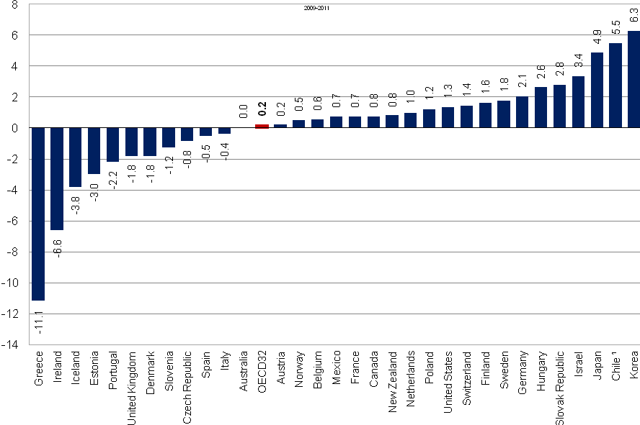

Source: OECD Health Statistics 2014

  - Total health spending in Ireland in 2012 accounted for 8.9% of GDP which is significantly below the OECD average of 9.3% as outlined in Figure 4. Health spending, as a share of GDP is much lower in Ireland than in other European Countries such as Austria, Denmark, France, Germany, the Netherlands and Switzerland where it accounts for 11% or more of GDP.

Figure 4: Health expenditure as a share of GDP, OECD countries, 2012 or latest year
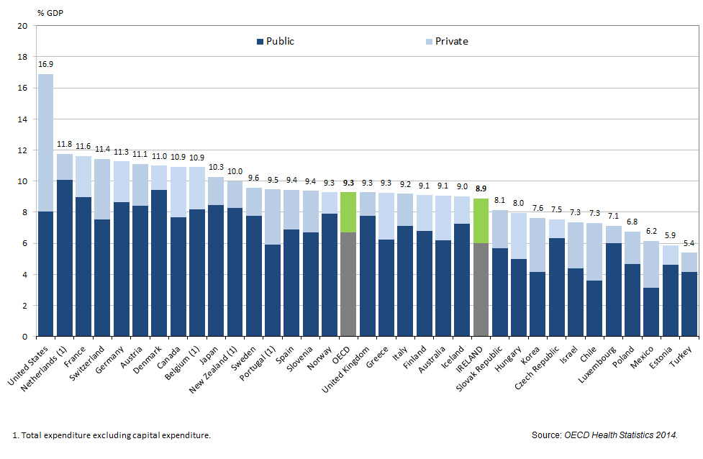
IHCA Submission:
There is a pressing need to increase frontline acute hospital resources in the 2015 Budget to enable the delivery of high quality, safe care to patients in contrast with the current overstretched situation. Otherwise, the delivery of care will be adversely affected leading to increased delays in treating patients and growing numbers on waiting lists. It is a major concern that acute hospital expenditure in treating patients requiring care in the first five months of 2014 was €104.8m over budget and that the scale of the underfunding in eight acute hospitals was between 10% and 21%. If increased resources are not provided, it will increase the risk that a growing number of patients will not be treated within a medically appropriate timeframe. Underfunding of acute hospitals is a matter that needs to be urgently addressed in the 2015 Budget.

- Patient Demand for Acute Hospital Care continues to exceed NSP targets.

  - Demand for patient care in acute public hospitals has continued to increase in recent years, driven by our ageing population and the reduction in the number of patients with private health insurance.

  - Hospital consultants and doctors have struggled in recent years to treat an increasing number of acute hospital patients due to the severe reductions in acute hospital budgets. NSP targets and related funding have consistently underestimated patient demand for hospital care, as outlined in Table 2 below.

  - Table 2 and Figure 5 confirm that the number of patients treated in recent years and to date in 2014 has exceeded the targets included in the NSP. This is clearly demonstrated by the increase in the number of inpatients and day case patients treated compared with the May targets in the 2014 NSP. In total 588,921 inpatients and day case patients were treated up to the end of May this year. While this is an increase of 4,958 (+0.85%) on the NSP year to date target it is a decrease of 11,970 patients (-2%) on the number of patients treated in the same period last year (600,891). It is clear that the substantial cuts in hospital budgets are negatively impacting on the delivery of acute services.

Table 2: Hospital Activity: 2007 – 2014
 | 2007 | 2008 | 2009 | 2010 | 2011 | 2012 | 2013 | 2014(YTD) | % Change  2007/  2013
% Outturn / Tgt  Inpatient Discharges | +2.5% | +1.8% | +3.7% | +8.8% | +2.5% | +7.4% | +0.97% | +.02%
Outturn | 614,196 | 604,320 | 595,022 | 588,860 | 588,623 | 603,911 | 595,109 | 248,649 | -3.1%  (19,087)
Target |  | 593,859 | 573,360 | 540,993 | 574,400 | 562,133 | 600,887 | 247,919
% Outturn / Tgt  Day-case | +2.5% | +7.9% | +4.4% | +5.7% | +6.5% | +5% | +0.79% | +1.2%
Outturn | 590,672 | 637,140 | 675,611 | 728,269 | 804,274 | 826,825 | 836,789 | 340,272 | +42%  246,117
Target |  | 590,016 | 647,000 | 689,310 | 755,100 | 787,557 | 830,165 | 336,044
% Outturn / Tgt  Emergency Admissions | +3% | -0.3% | -.08% | +11.7% | +3.1% | +7.5% | +3.3% | -1.4%
Outturn | 370,040 | 368,341 | 366,690 | 369,031 | 372,644 | 384,641 | 393,846 | 167,674 | +6.4%  23,806
Target |  | 369,368 | 367,000 | 330,298 | 361,400 | 357,600 | 380,990 | 169,941
Source: Annual and May 2014 Performance Reports

Figure 5: Hospital Activity 2007 – 2013
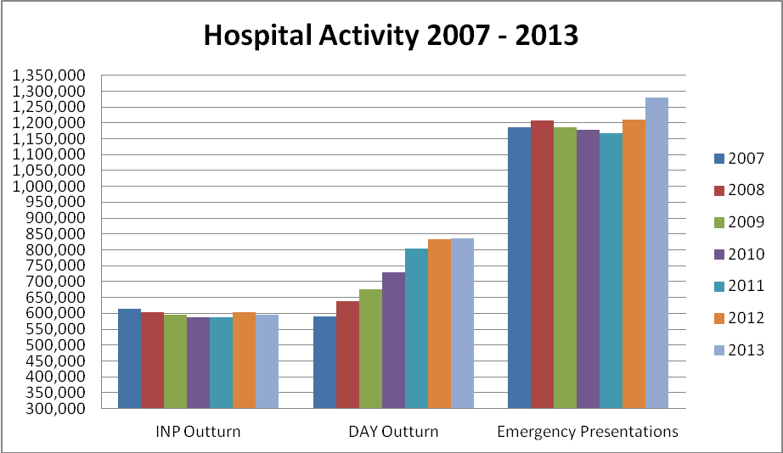
Source: HSE Performance Reports

  - There is now a major concern that the progress achieved in treating an increased number of patients in recent years is being undermined due to a lack of frontline resources as demonstrated by the reduction (-3.5%) in day case patients treated up to the end of May this year. A total of 340,272 day case patients were treated up to May 2014 which is 12,500 below the same period in 2013 as shown in Table 3.

Table 3: Daycase Numbers (May 2013 versus May 2014)
May 2013  Day case patients treated | Reduction 2013v 2012 | May 2014  Day case patients treated | Reduction 2014 v 2013
352,772 | -1.3% | 340,272 | -3.5%
Source: HSE Performance Reports May 2013 & May 2014

  - Key trends:
- The number of inpatients treated has returned to the levels of 2009.
Targets for inpatient care have been consistently set below the actual level of demand as has funding for the service. The target for 2014 (591,699) is not a true reflection of the level of demand for inpatient care taking account of the demand levels in the last 7 years and allowing for demographic and health insurance developments. The reported actual number of inpatients treated up to May equaled 248,649, 0.2% above the NSP target and similar to the same period last year.

- Day-case patients treated in 2013 was 42% or 246,117 higher than in 2007.
However, in the first 5 months of this year, 12,500 (-3.5%) fewer day-case patients were treated than in the same period last year. This has given rise to an increase in elective waiting lists (see section 4.3).

- Emergency presentations were 91,416 (+7.7%) higher last year than 2007.
This substantial increase in the level of emergency presentations arises at a time when the funding for acute hospitals has been cut severely. The increase is due to a number of factors, including the following:

- A general increase in demand for healthcare services due to the fact that Ireland has a growing and ageing population.
- The decline in the number of people covered by private health insurance.
- Delays in elective treatment resulting in poorer patient health leading to increased presentations in emergency departments.

IHCA Submission:
The successive reductions in acute hospital budgets have restricted the delivery of acute services over the last number of years. The number of day case patients treated up to May 2014 has declined by 12,500 or 3.5% due to the rationing of care. Increased funding for acute hospitals is required to address the constraints applying to acute service delivery.

- Waiting Lists.

  - The capacity of hospitals to reduce waiting lists is constrained due to the lack of frontline resources, especially the failure of the acute hospitals to attract and recruit the required number of hospital Consultants and maintain sufficient frontline staffing levels.

  - The HSE plans to reduce its workforce to approximately 98,000 whole time equivalents (WTE’s) by the end of 2014. This is a net reduction of 2,600 WTEs in 2014 on top of the reduction of 15,754 since 2007. The shortage of frontline staff in acute hospitals is impacting negatively on the capacity to effectively treat patients thereby increasing waiting lists.

  - Inpatient & Day-case Waiting Lists.

There were 50,689 inpatient and day case patients awaiting care in May 2014 of which 4,649 were children. This is an increase of 5% compared with May 2013.

Table 4: Inpatient and Day-case Elective Waiting Lists, 2013 – 2014
Inpatient & Day-case Elective  TOTAL | TOTAL WAITING May 2013 – May 2014
 | May 2013 | May 2014
 | 48,279 | 50,689
May 2014
Adult | 0-20 weeks | >20 weeks | TOTAL – May 2014
Inpatient | 11,436 | 1,889 | 13,335
Day-case | 29,326 | 3,379 | 32,705
Child |  |  | 0
Inpatient | 1,826 | 719 | 2,545
Day-case | 1,737 | 367 | 2,104
 |  |  | 50,689
Source: HSE Performance Reports.

IHCA Submission
There were 50,689 patients awaiting elective care in May 2014; a 5% increase on May 2013. It is clear that the deep acute hospital budget cuts have increased the number of patients awaiting day case treatment. It is essential that hospital budgets are based on more realistic estimates of projected demand, so that acute hospitals can provide care to an increasing number of patients without delays.

  - Outpatient Waiting Lists.
The data in Figure 6 records the current total number of outpatients waiting for their first consultant appointment. In each of the highlighted categories (0-6 months, 6-12 months, over 12 months and totals), the number of outpatients waiting has increased from February 2014 through to May 2014 as has the number waiting for 0-6 and 6 -12 months compared with May 2013.

Figure 6: Outpatient Waiting List; 2013/2014
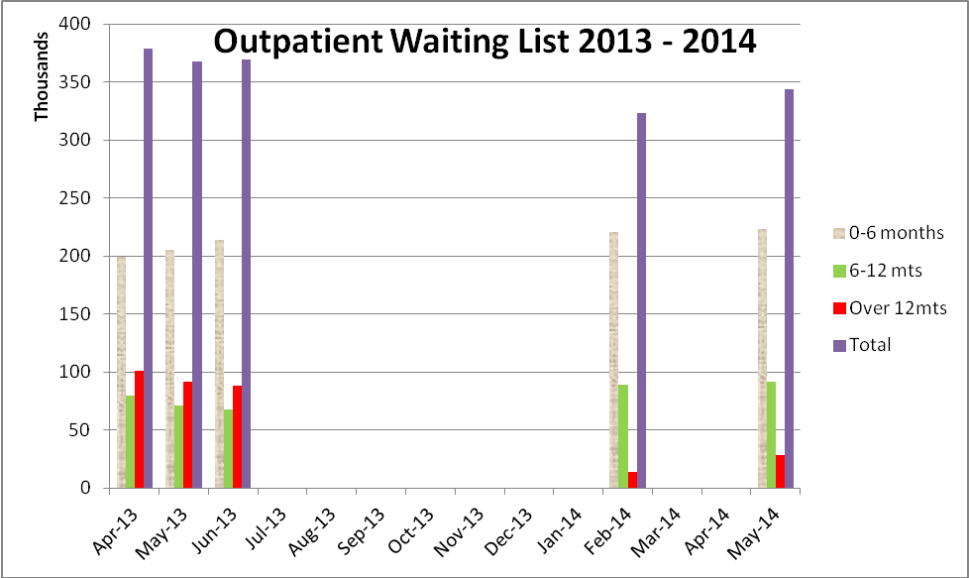

Outpatient Waiting List | 0-6 months | 6-12 mts | Over 12mts | Total
April 2013 | 199,513 | 79,153 | 100,498 | 379164
May 2013 | 205,476 | 71,122 | 91,195 | 367,783
June 2013 | 213,653 | 67,839 | 87,847 | 369,339
February 2014 | 220,992 | 88,874 | 13,438 | 323,304
May 2014 | 223,498 | 91,729 | 28,185 | 343,412
Source: National Treatment Purchase Fund and May 2014 HSE Performance Reports.

  - While the total number of patients on waiting lists declined from April 2013 to February 2014, the numbers waiting have started to increase again for all lengths of wait.

  - The principal reasons for the waiting lists include:
- A lack of frontline resources to cater for the overall level of inpatient, day-case and outpatient demand.
- Insufficient consultant & doctor staffing levels as Ireland has around two thirds the number of hospital consultants recommended in the Hanly Report a decade ago. Based on the number of doctors licensed to practice, Ireland has 2.7 doctors per thousand population according to the OECD Health at a Glance 2013 Report. On that basis, Ireland has 15% fewer doctors than the OECD average of 3.2 per thousand and it has about 30% fewer doctors than Austria, Italy, Sweden, Germany, Switzerland, Spain, France etc.
- Vacant consultant posts and recruitment difficulties due to a severe reduction in the number of eligible applicants for advertised posts, arising from the unilateral cut in new consultant salaries and increasingly difficult workplace conditions. Up to 20% of the approved consultant posts in acute hospitals and mental health services are either vacant or filled on a temporary basis through agencies at a much higher cost than recruiting permanent consultants.

IHCA Submission:
It is vital that acute hospitals are provided with increased frontline resources so that they can care for patients on a timely basis. There is an urgent need to address the problems impacting negatively on recruitment and retention of consultants in Ireland and the failure to fill vacancies with permanent appointments.

Bed Stock.
  - At a time of increased demand for hospital care due to our increasing and ageing population, the number of publicly funded inpatient beds is about 10% below 2006 levels. Ireland’s reported acute inpatient bed capacity at 3 per 1000 population is low in comparison with other countries and the OECD average of 4.8 per 1,000 population. Ireland also has an extremely high bed occupancy level which impacts on infection control and patient care.

  - The number of clinically discharged patients occupying acute hospital beds continues to be a major issue, with some 670 beds unavailable to new admissions. This is equivalent to Beaumont Hospital or University Hospital Galway being closed throughout the year (Figure 7).

Figure 7: weekly delayed discharges Apr/May 2014
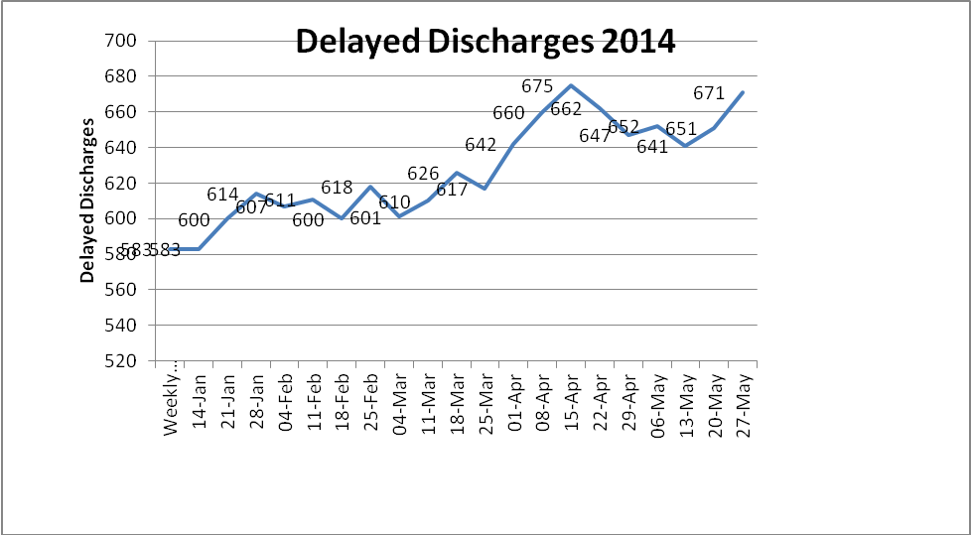
Source: May 2014 Performance Assurance Reports

IHCA Submission
The Association strongly recommends that increased frontline resources are provided to utilise the existing bed and theatre capacity to the optimum as this is urgently required to treat the increasing numbers of patients presenting for care. The failure to transfer clinically discharged patients to step down care is the equivalent to Beaumont Hospital or University Hospital Galway being closed throughout the year every year. Closed beds and restricted access to theatre facilities and beds in operation represent an enormous loss to the health system and wider public.

- Health Insurance

The number of people with health insurance has declined by over 11% since 2008. There is a concern that the number of people giving up health insurance has been exacerbated by the reductions in tax relief included in this year’s budget.

Overall, the cost of providing care to private patients has increased for a number of reasons in recent years despite reductions in the fees that insurers are paying to Consultants. In the past two years, Consultants costs have increased substantially due to increases of around 33% and 42% in the cost of clinical indemnification in 2013 and this year respectively.

Given the continuing upward pressure on the cost of providing care, it is critically important that the increased cost of clinical indemnification is addressed and that tax relief on private health insurance is returned to the levels that applied prior to the 2014 budget cuts.

- Mental Health Funding

  - There is a concern that the ring-fenced additional funding of €35million allocated to Mental Health Services in 2013 was used to fund the overall health budget deficit. As of May 2014, additional funding of €20 Million allocated to Mental Health in the 2014 budget had not been spent giving rise to renewed concerns.

  - Mental Health funding has been cut by almost €250m, or 25%, based on the 2009 to 2014 figures (table 6), at a time of increased demand and in circumstances where significant shortfalls in the provision of services have arisen. The Mental Health division is reporting breakeven at the end of May 2014 arising principally from the inclusion of the suicide prevention budget. Without this positive variance from the National Office for Suicide Prevention, there would have been a €1m or 0.4% deficit.

  - Mental Health services are seriously understaffed. There were 584 WTEs vacancies in April 2014, some 6% below the staffing ceiling of 9,611.

Table 6: Current Expenditure for Mental Health, 2009 - 2014
Mental Health  Provisional Outturn | Provisional Out-turn  €’000
2009 | 1,006,682
2010 | 963,324
2011 | 712,000
2012  2013  2014 | 711,000  733,000  765,000
% Change 2009 – 2014 | - 241,682 -25%
Source: Department of Finance, National Service Plan 2014

  - The failure to recruit frontline staff as planned and fill consultant psychiatrist posts on a permanent basis is undermining the provision of mental health care services to patients. This is a particularly worrying development at a time when demand for care has grown substantially due to the country’s increasing and ageing population.

  - In May 2014, 76% of accepted referrals (against a target of 75%) to child and adolescent Community Mental Health Teams were offered a first appointment and seen within three months. The performance in May shows an increase of 3% compared with the April. In addition, the number of involuntary admissions to acute adult units in 2013 totaled 1,741, a 5% increase on 2012.

  - Child and Adolescent Mental Health Services have reported an increase in the number on waiting list to 3,029 cases, a 11% increase on the same period last year.

  - The Association is concerned that comprehensive mental health activity data is not included in the HSE Performance Reports. The data included in the reports changes over time making it difficult to comprehensively map current performance against Vision for Change targets and year on year trends.

IHCA Submission:
The additional €20 million provided for Mental Health Services in the 2014 Budget must be used on a timely basis to recruit additional staff and improve care for patients. This funding should be increased in next year’s budget to improve staffing levels further.

- Staffing Issues.

  - A total of 97,017 WTEs were employed by the HSE in May which is a reduction of 15,754 or 14% when compared with September 2007.

  - Further cuts totaling 2,600 in staffing levels are planned this year. It is essential that frontline staffing levels are maintained and increased as this is essential to deliver safe, high quality care to patients without delay.

  - Currently, Ireland has approximately two thirds the number of Hospital Consultants recommended a decade ago in the Hanly Report. In the interim, the demand for care has grown substantially due to the country’s increasing and ageing population. In some specialties, the country has around one third to half the number of hospital Consultants compared with the recommended international specialty norms.

IHCA Submission
It is essential that the Consultant recruitment and retention crisis, that is causing a medical brain drain, is addressed urgently. The unilateral 30% cut in new Consultant salaries introduced in October 2012 in breach of the Croke Park Agreement must be reversed to ensure the country can recruit and retain the number and calibre of Consultants it needs.

- Conclusion

Repeated reductions in hospital and mental health budgets over the past five years have undermined the delivery of frontline acute hospital and mental health services. There are a number of serious challenges impacting adversely on acute hospital and mental health services which are at a crisis point:-

- There is insufficient funding to enable the delivery of safe, high quality acute hospital and mental health services taking account of increased demand for care.

There is inadequate frontline resources which is preventing the optimum use of existing bed, theatre and other facilities.

The health services management and hospitals have failed to recruit and retain the required number of Hospital Consultants to provide care to patients without delays.

In conclusion, the Association is calling for increased funding for frontline healthcare services so that the challenges set out in this submission are addressed.

24 JULY 2014

Excluding figures for palliative care.

